National University of Technology

Computer Science Department

Semester Spring– 2025
Program: Artificial intelligence
Course: Programming for AI Lab
Course Code: CS283

Lab Report- 08

Submitted To: | Submitted By:
Umar Aftab | Muhammad Ahad Imran
 | F23607034

Julia Programming

1. Hello, World!
println(" Hello , Julia !")
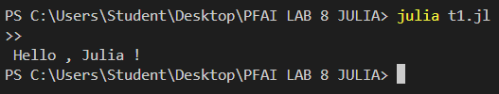

2. Variables & Constants
x = 5
const Y = 10
x += 1
println("x = $x, Y = $Y")
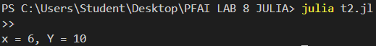

3. Arithmetic Operations
a = 10
b = 3
println("Sum: $(a + b)")
println("Product: $(a * b)")

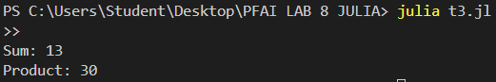

4. Conditionals (if-else)
n = -5

if n > 0
println("Positive")
elseif n < 0
println("Negative")
else
println("Zero")
end
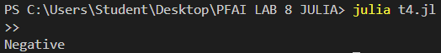

5. Loops (for, while)
for i in 1:3
println("Iteration $i")
end
counter = 1
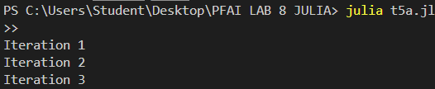
counter = 1

while counter <= 3
println("Counter: $counter")
global counter += 1
end

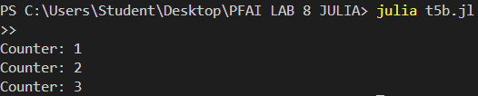

6. Functions & Control Flow
function square(x)
return x^2
end

println("Square of 5: $(square(5))")
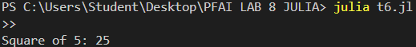

7. Multiple Dispatch
add(x::Int, y::Int) = x + y
add(x::String, y::String) = string(x, y)

println(add(3, 5))
println(add("Hello ", "Julia"))
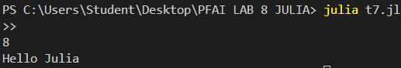

8. Arrays
arr = [10, 20, 30]
println("First element: $(arr[1])")
push!(arr, 40)
println("Updated array: $arr")

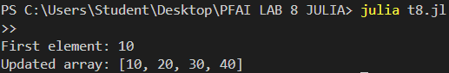

9. Tuples & Dictionaries
tup = (1, "apple", 3.14)
println("Tuple: $tup")

dict = Dict("name" => "Alice", "age" => 30)
println("Age: $(dict["age"])")
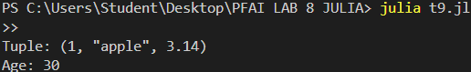

10. Structs
struct Point
x::Float64
y::Float64
end

p = Point(1.0, 2.0)
println("Coordinates: ($(p.x), $(p.y))")
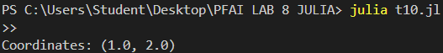

11. try-catch
try
println(10 / 0)
catch e
println("Error: $e")
end
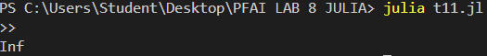

12. Read/Write Files
open("data.txt", "w") do file
write(file, "Julia is fast!")
end

content = read("data.txt", String)
println("File content: $content")
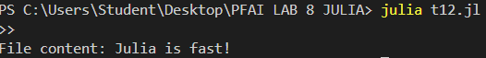

13. DataFrames.jl
using DataFrames

df = DataFrame(Name=["Alice", "Bob"], Age=[25, 30])
println(df)
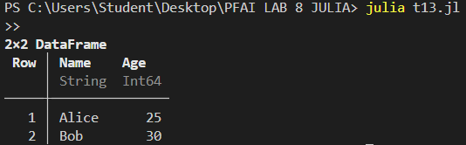

14. Plots.jl
using Plots

x = 1:10
y = x .^ 2
plot(x, y, title="y = x^2")
savefig("plot.png")
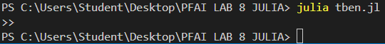
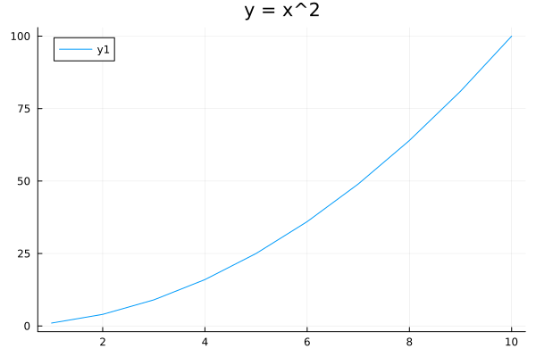

15. Flux.jl
using Flux
using Random

# Set random seed for reproducibility
Random.seed!(123)

# Create a simple linear model
model = Dense(1 => 1)

# Manually set initial weight to ensure positive slope
model.weight .= Float32[1.0]
model.bias .= Float32[0.0]
println("Initial model parameters: Weight = $(model.weight), Bias = $(model.bias)")
# Create training data with consistent Float32 type
X = Float32[1.0, 2.0, 3.0]
Y = Float32[2.0, 4.0, 6.0]

# Reshape inputs to column vectors with correct dimensions
data = [(reshape([X[i]], 1, 1), reshape([Y[i]], 1, 1)) for i in 1:3]

# Define loss function
function loss(m, x, y)
return Flux.mse(m(x), y)
end

# Calculate total loss over the dataset
function total_loss()
sum(loss(model, x, y) for (x, y) in data)
end

# Set up optimizer with lower learning rate for stability
opt = Flux.setup(ADAM(0.01), model)

# Training loop with more epochs
num_epochs = 1000
println("Starting training...")

for epoch in 1:num_epochs
# Calculate gradients and update weights
for (x, y) in data
grad = gradient(m -> loss(m, x, y), model)
Flux.update!(opt, model, grad[1])
end

# Print progress every 100 epochs
if epoch % 100 == 0 || epoch == 1
current_loss = total_loss()
println("Epoch $epoch: Loss = $current_loss, Weight = $(model.weight[1]), Bias = $(model.bias[1])")
end
end

println("\nTraining complete!")
println("Final model parameters: Weight = $(model.weight[1]), Bias = $(model.bias[1])")

# Test the model on training data
println("\nResults on training data:")
for (x, y) in data
predicted = model(x)
println("Input: $(x[1]), Target: $(y[1]), Prediction: $(predicted[1])")
end

# Test with new data
test_input = reshape(Float32[5.0], 1, 1)
prediction = model(test_input)
println("\nTest with new input:")
println("Input: 5.0, Expected: 10.0, Prediction: $(prediction[1])")
